MINISTRY OF SCIENCE AND EDUCATION NATIONAL TECHNICAL UNIVERSITY “KHARKIV POLYTECHNIC INSTITUTE”

DEPARTMENT OF SOFTWARE ENGINEERING AND MANAGEMENT INFORMATION TECHNOLOGIES

Report from lab#1

Discipline “Fundamentals of Database”

Executed by: Student of group 1.КН.201.8e1

CHUKWU IRELE AMORIN

Checked by: Senior lecturer

Kharkiv

2020

**I. Problem description**

Some enterprise purchases products from various suppliers (both legal en-tities and individual entrepreneurs). Purchasing is performed using batches and formalized as supply contracts. Each supply contract has unique number and might be concluded with a single supplier. Documents for each contract include product name, supplied amount, and price (in UAH).

Database with following tables might be used to store and process such information using DBMS Access.

1. “Suppliers” table

Each table entry contains following fields:

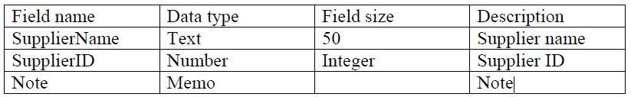

2. “LegalEntities” table

Each table entry contains following fields:

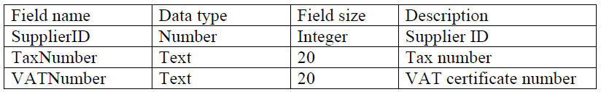

3. “IndividualEntrepreneurs” table

Each table entry contains following fields:

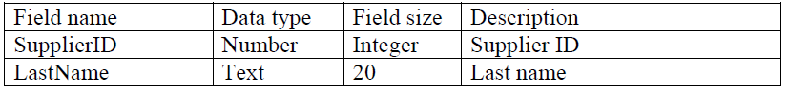

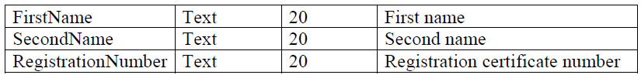

4. “Contracts” table

Each table entry contains following fields:

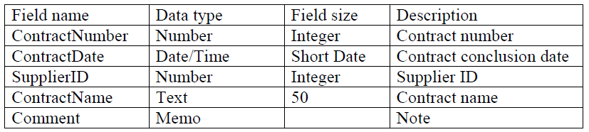

5. “Supplied” table

Each table entry contains following fields:

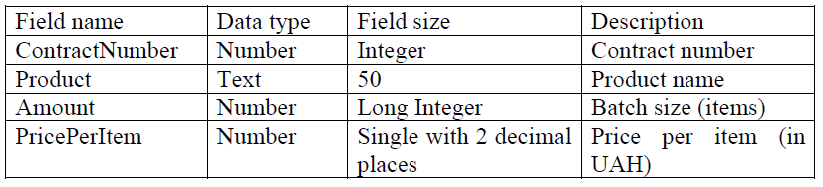

**Steps to taken for the lab work :**

1. Create Database .
2. Create each tables with required constraints .
3. Create the relationships to connect the tables .
4. Fill the tables with data .

**Solutions :**

**Table:**

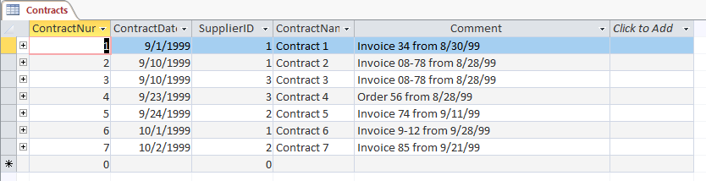

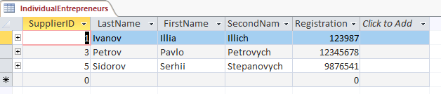

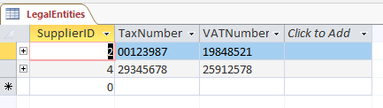

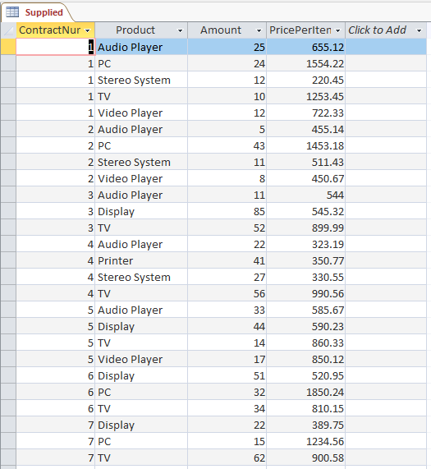

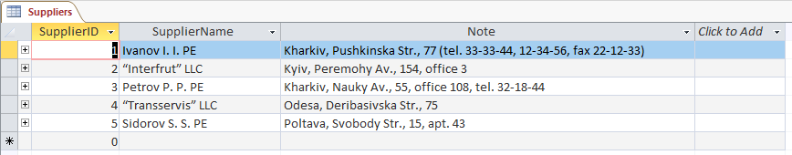

**Relationships:**

